# SMA Strategy Definition - Answer with Explanation

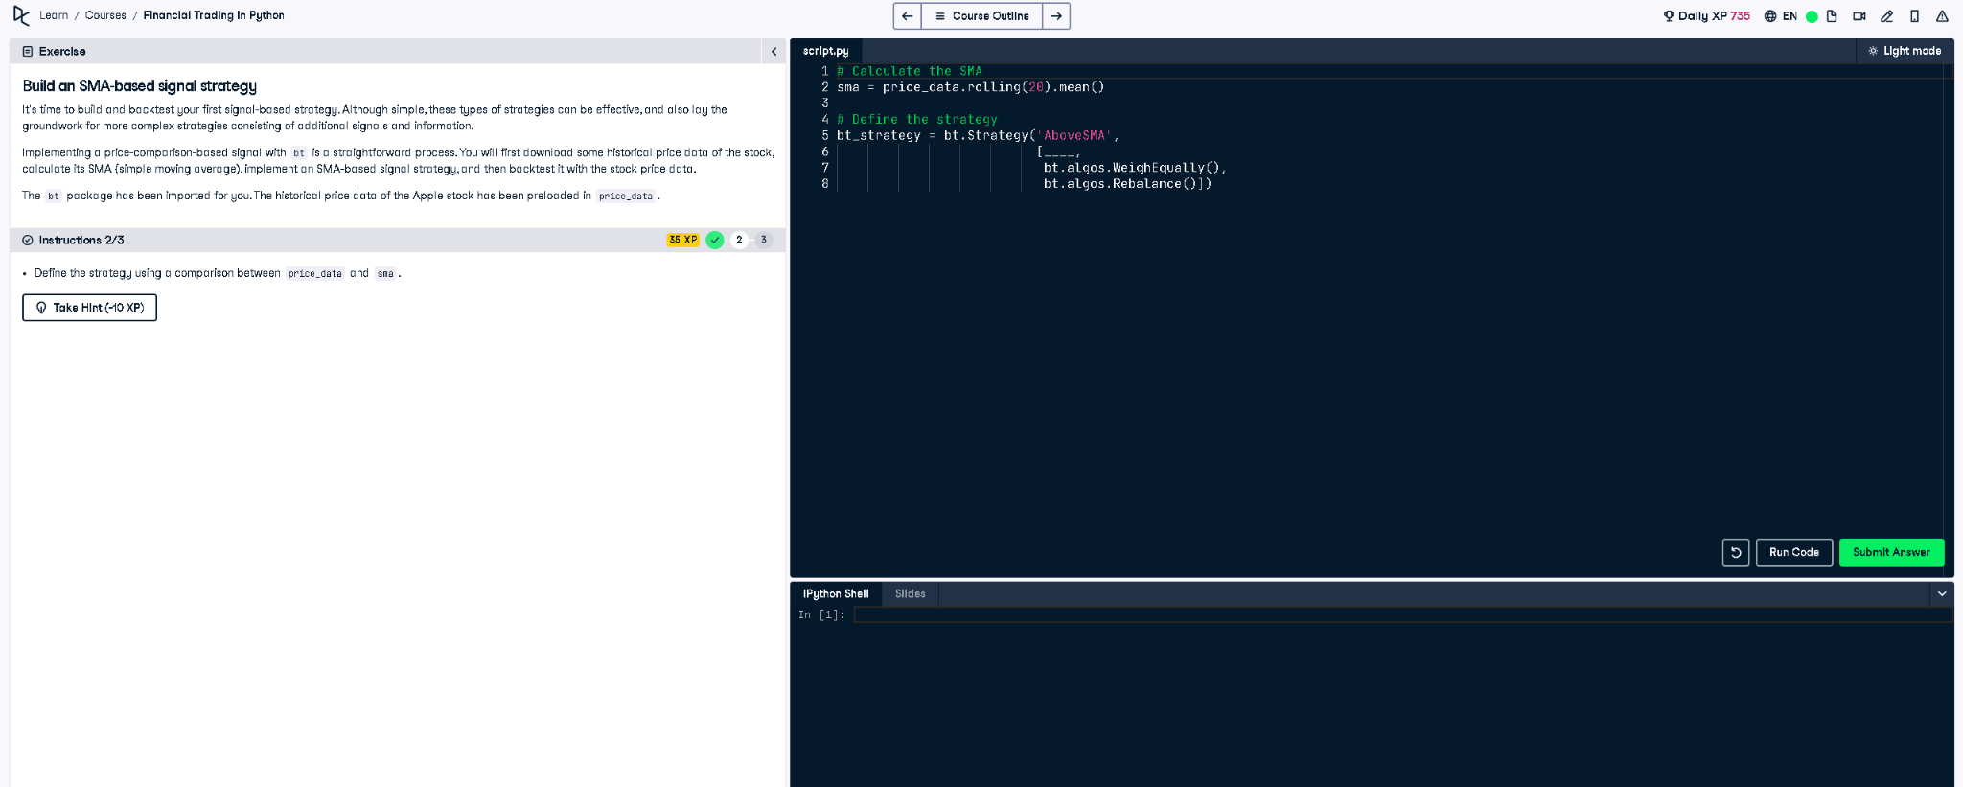

## ✅ Full Python Answer

# Calculate the SMA (Simple Moving Average)  
sma = price_data.rolling(20).mean()  
  
# Define the strategy  
bt_strategy = bt.Strategy('AboveSMA',  
 [  
 bt.algos.SelectWhere(price_data > sma),  
 bt.algos.WeighEqually(),  
 bt.algos.Rebalance()  
 ])

## ✅ Explanation in Simple Words (50 words)

This strategy buys the asset only when its current price is above the 20-day moving average (SMA). It compares each value in price_data to the SMA. If the price is higher, it triggers a buy. This approach aims to capture upward trends and avoid sideways or falling markets.